CBC_5 Blockchain Based Skill Credentialing System
Ms.Shanker J
Assistant Professor
Presidency University,
Bangaluru, India
Shankar.j@presidencyuniversity.in

Sandya KJ
Computer Science and Engnieering Specilisation Blockchain Technology
Presidency university
India
Sandyakj17@gmail.com
Vinuta janardhan hegde
Computer Science and Engnieering Specilisation Blockchain Technology
Presidency university
India
Vinutahegde07@gmail.com
Nikitha S
Computer Science and Engnieering Specilisation Blockchain Technology
Presidency university
India
nikinikitha4040@gmail.com

Abstract— Centralized credentialing systems are linked to many disadvantages, e.g., the vulnerability to fraud and the manipulation of data; the credentialing verification is not efficient, as the issuance of credentials and their verification is done by the same person, i.e., by the credentialing issuer (i.e., the institution issuing credentials) and the credentials verifier. The number of people being issued with digital credentials has increased dramatically because of the online learning that is gaining popularity, and this has generated an urge to have an alternative way to issue skill credentials that is credible, efficient, and transparent. We would like to satisfy this craving by developing a skill credentialing framework in which the characteristics of a blockchain, a decentralized, irrevocable block, are utilized to establish a trustworthy and safe mode of storing information in electronic format about the people's digital credentials.
Under blockchain and smart contracts, learning institutions and training organizations will have the ability to issue skill certification records on behalf of their learners and offer each learner full control of his or her certification through a cryptography wallet. The system will assist the employers in checking the authenticity of the credentials directly, therefore, saving time and cost spent in checking credentials. This system prevents forgery and unauthorized tampering of the credential by a hash of the credential on the blockchain.
The decentralized web-based DApp and this application are made based on Ethereum smart contracts. Evidence is the fact that credentials may be created and checked or stored safely. Based on the experimental findings, Ethereum DApp implementation offers a higher degree of security and transparency and a higher degree of scalability, as opposed to traditional credential management systems. In addition, the implementation of Ethereum on the education system by provision of credible digital credentials will ensure a safe means of skills checks and meet the increased demand of authenticated digital credentials within the education system and in the job market.
Keywords— Blockchain, Skill Credentialing System, Digital Certificates, Smart Contracts, Decentralized Application (DApp), Ethereum, Credential Verification, Immutable Records, Secure Authentication, Distributed Ledger Technology.

Introduction
The increase in the rate of digital education and certification programs has transformed the process of learning and proving the skills of people. In spite of these advances, a majority of the currently used credential management strategies are based on centralized frameworks, which have several shortcomings. These are delays in validation of certificates in various institutions, chances of fraudulent certificates, chances of unsupported changes, and limited transparency in the verification systems. Since they are based on one party of authority, such systems tend to fail to create effectiveness and confidence within bigger cross-organizational environments.
In order to sufficiently address these issues, there is a more reliable alternative in the form of the deployment of decentralized technologies such as blockchain. The idea of blockchain lies on the distributed network and hence the information recorded by it cannot be modified by all and this gives an excellent level of integrity and security. This paper presents a credentialing model because it is founded on blockchain technology with the creation, storage, and verification of digital certificates considered the most essential components that are subjected to smart contractual regulation. The secure digital wallets will enable learners to share and access their credential. In the meantime, organizations can use real-time credential authentication without the assistance of third parties. This will boost the trust, minimize the frauds and a general verification can be easily conducted.

SYSTEM OVERVIEW

To adequately resolve these concerns, it has a more credible alternative in the deployment of decentralized technologies like blockchain. The concept of blockchain is based on the distributed network and it therefore follows that the information that is captured by it cannot be altered by everyone and this provides a very good degree of integrity and safety. The paper demonstrates a credentialing model since it is established on blockchain technology where the establishment, storing and authentication of digital certificates are considered most crucial elements that are liable to smart contractual regulation. The safe digital wallets will also allow learners to exchange and retrieve their credential. Meanwhile, without the services of third parties, organizations can perform real-time credential authentication. This will enhance the trust, reduce the frauds and a general check may be made easily.

Issuing a credential led to the smart contract of creating and storing the hash on a blockchain network forever. Students have access to their credentials which has secure wallet interface through which the student can control and share their records. To confirm that the certificate is submitted, the certificate is rehashed to produce a hash value and that is compared to the one in the blockchain. A successful match is a condition that validates the credential and, thereby, makes it resistant to unauthorized system changes, ensures transparency, and integrity.

B.Maintaining the Integrity of the Specification
The decentralized nature of blockchain and cryptography methods contribute to the credentialing system being more integrity-oriented. The credentials are turned into hash messages of a fixed length which exactly represents what they contain. Any alteration in the credential can be detected easily as only a few alterations made on the document will lead to a completely different hash. Another benefit of blockchain is that the integrity of data is increased as the records are spread across multiple nodes. This nullifies the risk of failure where the centralized storage has a point of failure that can be exploited to wipe out the entire system. Smart contracts consist of pre-defined rules and the credentials will only be created or updated by accredited institutions. This type of cryptographic security in conjunction with a decentralized validation will maintain a high level of confidence and trustworthiness.

SYSTEM DESIGN AND ARCHITECTURE

System Architecture Overview
It will be a multi-layered system, where it will be interacting with the user, blockchain processing, and data storage. Users layer is the learners, educational institutions and employers since they are part of the system by web based decentralized application. Application layer is employed to provide communication between the users and the blockchain network. The layer blockchain takes care of storage of credential hash and smart contracts to handle issuance of credentials and verification of credentials. Moreover, to have a possibility to scale and handle data with no problem, the files of the real certificates are stored in an off-chain data system. All these are; issuing credentials, hash generation, blockchain storage and hash comparison.

Functional Componenets
The system consists of a number of related components that render the system user friendly to operate. Institutions have an issuer interface to create and issue digital credentials. The learners gain access to the system using user interface that enables them to access and manage their certificates. The employers have a verification interface that compares the credentials with a hash value to verify them. The key component of the system that automates such processes is smart contracts that credit and authenticate them. All these contracts are done in safe and free environment without intermediaries.

Equations
This system is based on cryptographic hashing to verify the authenticity of the credentials.
A hash of a digital certificate is in the following form:
H=SHA256(D)

Drep is the digital certificate, and His is the value of the generated hash.
When verifying one, the authenticity condition is
H_generated=H_stored

When the values are equal then the credential is said to be valid, otherwise it is rejected.

Common Challenges and Mistakes in Blockchain based skill credentialing system.
Even though there are benefits, the process of shifting to a blockchain-based credentialing system has some challenges. Transaction costs may have an impact on the scalability of blockchain operations, especially on the public networks. Moreover, one can also develop secure smart contracts by making them not vulnerable. The other concern is privacy of the users and requirement to be open. There is a need to be cautious regarding sensitive information because the information contained in blockchains is publicly available. The credentials may also be lost due to the inadequate handling of cryptographic keys. The security, usability, and efficiency balance should be the answer to these problems.

IMPLIMENTATION AND RESULTS

System Architecture
The system is applied in decentralized form via blockchain technologies. Smart contracts are created and implemented to support the operations associated with the credentials, and a web-based interface allows interaction with the users. The architecture guarantees safe exchange between the users and the blockchain network.
Off-chain storage helps to minimize the load on the blockchain and enhance the work of the system. The deployment proves that blockchain can be a good tool to manage credential data securely and transparently.

Smart Contract Developmen
Smart contracts are created so as to automate some of the most important tasks like issuing certificates, authenticity, and cancelation of invalid certificates. These are contracts written on blockchain and implementing them in a decentralized fashion. The process of issuing the credential captures the value of the hash of the credential whilst the value of the verification process involves comparing the values of the hash with the verified values to ascertain authenticity. The revocation mechanism enables authorized entities to revoke credentials whenever required. This automation improves efficiency and saves time and use of manual operations.

Figures and Tables
Figure 1.System Architecture
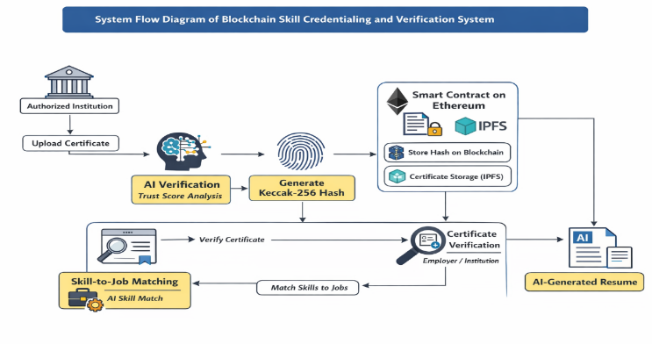
The system flow chart gives the entire issuance, storage, and validation process of the digital skill credentials by the blockchain mechanism. One such example is a workflow, in which an accredited institution is provided with a certificate into the system. The certificate is then subjected to an automated verification process and then it is recorded and this is to help in ensuring that the data used is homogeneous and valid. When it is validated, a cryptographic hash is made on the certificate and the generation is done through the help of an algorithm which provides a secure hash. This is a hash of the certificate that is a unique digital identity and which is utilized in the next validation.
Rather, a smart contract is stored in the blockchain as the hash of the contract, and the remainder of the certificate is stored out of band. The actual certificate file is the saved certificate file; the saved certificate file is stored in a decentralized storage scheme like IPFS that enhances the performance and minimizes the cost of material storage in the blockchain. The learner is able to keep and save his/her credentials and usually has an electronic wallet attached to it. Once the decision is made that a certificate has to be validated, a new hash of the issued document is being computed and compared with the one stored in the blockchain. Both of these values are held to be constant and in this instance the certificate is true and alleged to be true.
More characteristics like skill to job matching whereby validated credentials can be applied in the correct matching of the skills of the workers to the job are also present in the system. This system is secure, immutable and visible with decentralized store implying the automatic processes and cryptographic authentication and simplifying the validation procedure to the institutions and employers.

TABLE I COMPARISON BETWEEN TRADITIONAL AND BLOCKCHAIN-BASED CREDENTIALING SYSTEMS
Feature | Traditional System | Blockchain System
Security | Low | High
Fraud Risk | High | Very Low
Transparency | Limited | High
Verification Time | Slow | Instant
Central Authority | Yes | No

IMPLIMENTATION AND RESULTS
A stamp of approval is comparable to the process of checking and verifying certificates of the user through the assistance of blockchain-based hashing. It is then in a position to generate an accurate and reliable resume using this checked information. What is even more effective is that it also applies these approved skills to offer good fit employment opportunities. This is a paradigm shift in the connection between credential checking and employment seeking. It helps to bridge the gap between the job seekers and the job providers since it is easier to apply to jobs that the individual is eligible to perform. And to employers, it will entail that they do not have to sift through a mass of unqualified candidates in order to get the right man. The whole process of recruitment is rendered effective and dependable. It is simply about making the people find easier jobs that are a fit and the employers find the people that they need to get the job done.

Application Interface and System Workflow
The system proposed was put in place as a web-based decentralized application and was tested on desktop and mobile platform to enable usability and responsiveness. The application offers two categories of users, namely, job seekers and employers, and it is oriented on credential validation, resume creation, and job matching.

Figure 1. Login Interface (Desktop View)
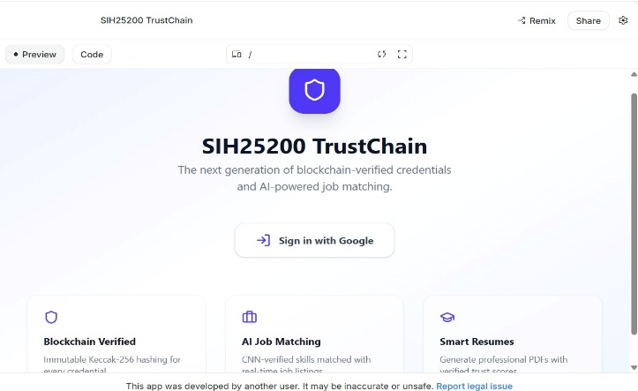
The desktop interface is the entry point of the application. Users are able to log in safely using Google authentication. The homepage also showcases the main functionality of the system, which is verifying credentials based on blockchain, matching job based on AI, and generating resumes automatically. This interface guarantees an easy-to-use experience and is well-informed about the purpose of the platform.

Figure 2. User Role Selection (Mobile View)
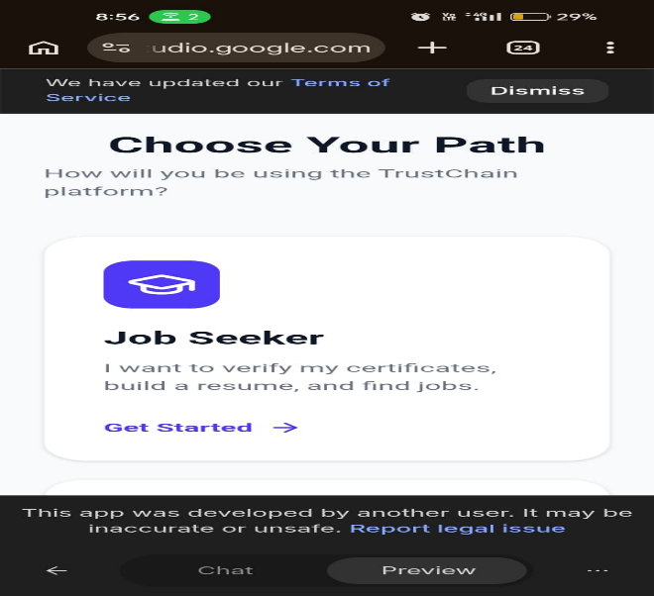

The employer verification portal allows businesses to verify the credentials of candidates in a secure and quick manner. The certificate information can be uploaded or typed in by employers and converted to a hash value comparing it to the information stored on the blockchain. In case both values are equal, the credential is said to be valid. Also, the employers can view the profile of the candidate, which includes confirmed resume and employment match and make faster and more reliable decisions about their employment.
Figure 3. User Dashboard Navigation (Mobile View)
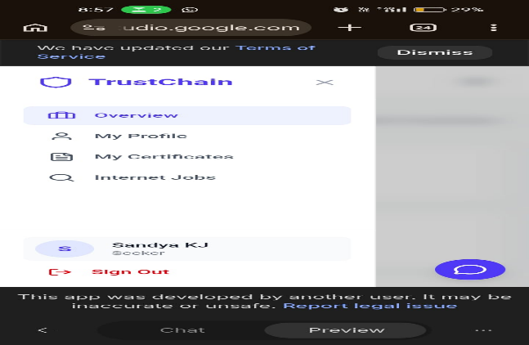
After logging in, users would be redirected to a dashboard where they can access several functionalities. The navigation menu consists of profile management, certificate handling, and job search. The dashboard is set in such a way that it provides a smooth interaction and easy access to all the features in the system.
CONCLUSION
The suggested skill credentialing system is a blockchain-based system that offers safe and effective alternative to credential management approaches. The system eliminates chances of tampering and fraud of digital credentials by means of decentralization, immutability, and automated smart contracts. The implementation proves that blockchain technology could be highly relevant in terms of transparency, less time of verification, and increased confidence among stakeholders. With the continued growth of digital education, these systems can be important in the development of trusted and universally recognized credential verification systems.

References

- J. Wang, X. Li, and Y. Chen, “Blockchain-Based Digital Credential Verification System for Education and Employment,” arXiv preprint arXiv:2502.09431, 2025.

- A. Kumar and S. Patel, “Decentralized Skill Certification Using Blockchain and Smart Contracts,” arXiv preprint arXiv:2503.11782, 2025.
- L. Fernández, M. López, and R. García, “Privacy-Preserving Academic Credential Management Using Blockchain,” arXiv preprint arXiv:2501.06354, 2025.
- S. Nakamura and T. Ishikawa, “Secure and Scalable Blockchain Framework for Digital Skill Credentials,” in Proc. 2025 IEEE Int. Conf. on Blockchain and Cryptocurrency (ICBC), Sydney, Australia, 2025, pp. 214–221.
- R. Hasan and K. Salah, “Blockchain-Based Skill Certification for Trustworthy Employment Verification,” IEEE Access, vol. 13, pp. 45210–45225, 2025.

- K. Kabashi, A. L. Orozco, and D. Stojanovic, "Digital Credential Verification Using Blockchain Technology," Future Internet, 2024.

- M. S. Mukta, M. Rahman, and M. Hasan, "Blockchain-Based Educational Certificate Verification System," Journal of Information Security and Applications, 2023.

- P. Khati, R. Sharma, and S. Verma, "A Blockchain Framework for Secure Academic Credential Management," International Journal of Computer Applications, 2023.
- M. A. Rahman, M. Islam, and S. Ahmed, "Secure Skill Certification Using Blockchain Technology," IEEE Access, 2023.
- R. Kaneriya and D. Patel, "Blockchain-Based Digital Credential System for Educational Institutions," Procedia Computer Science, 2023.

